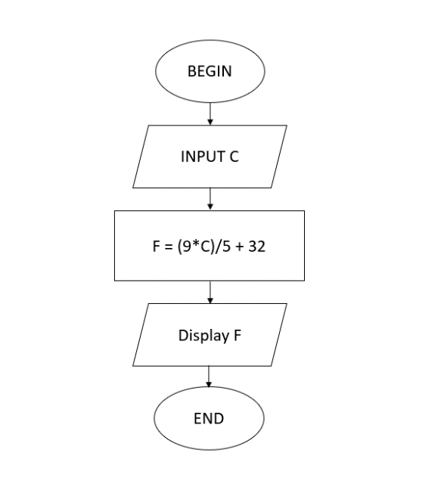BEGIN

INPUT C

F = (9\*C)/5 + 32

Display F